High Level Architecture Overview
  - Python – Django Application Stack

Table of Contents
1 High Level Overview 3
1.1 Front End: 3
1.1.1 Bootstrap 4+: 3
1.1.2 React.js: 4
1.2 Backend Stack 4
1.2.1 Django 4
1.2.2 Django Rest Framework 4
1.3 Database 4
1.4 Cache, MQ and Realtime Updates 4
1.5 Microsoft Office SharePoint DMS 5
1.6 LDAP Authentications 5
1.7 High Level Overview of System Interactions 5
1.8 Usage of internal libraries 6
2 Front End 8
2.1 React Libraries / Modules: 8
2.2 Screen Views 8
2.3 Grid Component 9
2.4 UI Component 9
2.5 Modular, Portable and Higher Order Components 9
3 Backend 10
3.1 Data Modeling 10
3.2 Serializers – DRF 10
3.3 Audit Trail 10
3.4 Roles and Permission 10
3.5 Logging 10

High Level Overview

A technology stack for a typical enterprise web application portals is proposed. The technology stack comprise of Full Stack layers of React + Django. Below is the birds eye view of the layers of the technology stack:

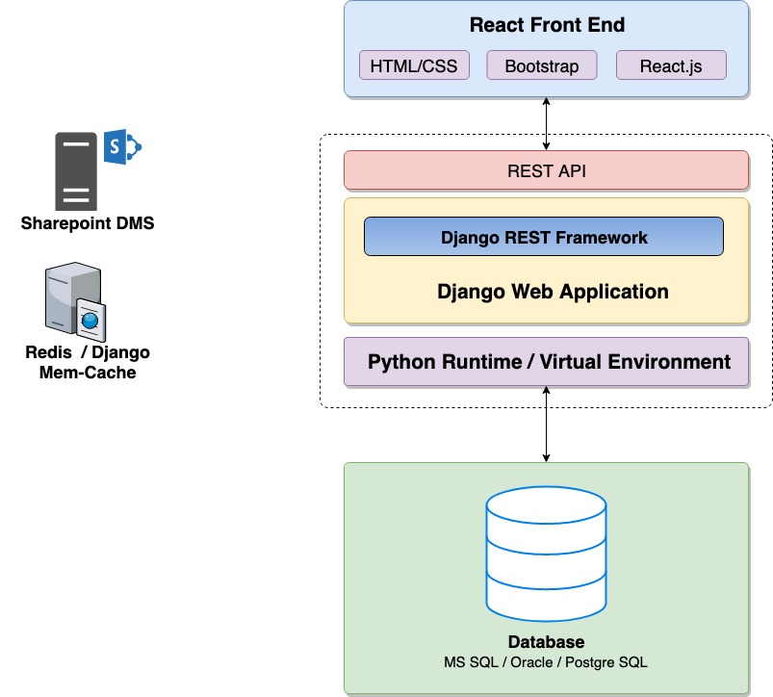
Figure 1 : Django + React Technology Stack for Enterprise Web Portals

Front End:

Front end of the web application should be developed by building client side web pages with good user experience and considerable compatibility to multiple devices:

Bootstrap 4+:
Bootstrap is a free and open-source CSS framework directed at responsive, mobile-first front-end web development. It contains CSS and JavaScript-based design templates for typography, forms, buttons, navigation and other interface components.

All Web Pages should be developed using bootstrap library and responsive compliant.

React.js:
React is a JavaScript library for building user interfaces. It is maintained by Facebook and a community of individual developers and companies.

Backend Stack

Django
Django is a Python-based free and open-source web framework, which follows the model-template-view architectural pattern:
- Django has to be used as server side framework for creating web application and REST APIs.
- In majority of the cases REST API based server side stack has to be created. But on requirement basis, conventional Django Based web application can be built.
- In case any other server side technology has to be used, a proper approval process with justification has to be followed.

Django Rest Framework
Django based REST Web API Library which helps rapidly develop RESTful web services.

Database
Following Database can be used as per requirements and discussion and decision of internal team:
- Oracle
Oracle Database is a proprietary multi-model database management system produced and marketed by Oracle Corporation.
- MS SQL Server
Microsoft SQL Server is a relational database management system developed by Microsoft.
- PostgreSQL
PostgreSQL, also known as Postgres, is a free and open-source relational database management system emphasizing extensibility and technical standards compliance.

Cache, MQ and Realtime Updates
Following libraries / packages can be considered for caching and message queueing.
- Redis
Redis is an in-memory data structure project implementing a distributed, in-memory key-value database with optional durability. Redis supports different kinds of abstract data structures, such as strings, lists, maps, sets, sorted sets, HyperLogs, bitmaps, streams, and spatial indexes.
- Socket IO
Socket.IO is a JavaScript library for real-time web applications. It enables real-time, bi-directional communication between web clients and servers.
- Rabbit MQ (For Low Throughput Systems)
RabbitMQ is an open-source message-broker software that originally implemented the Advanced Message Queuing Protocol and has since been extended with a plug-in architecture to support Streaming Text Oriented Messaging Protocol, Message Queuing Telemetry Transport, and other protocols.
- Zero MQ (For High Throughput Systems)
ZeroMQ is a high-performance asynchronous messaging library, aimed at use in distributed or concurrent applications.

Microsoft Office SharePoint DMS

All file uploads should be stored and retrieved from MOS DMS of Essar steel. The DMS should be used and decorated in such a way that application just uses an adapter to connect to DMS and adapter should be able to port any of the DMS in future without any change or negligible change in the transaction code.

LDAP Authentications
Applications will require authentication from central LDAP server(s) of the organisation. All applications, unless specified, will be required to use the central LDAP Authentication for application login purposes.

High Level Overview of System Interactions

The system will interact with multiple systems and services in the eco-systems. A overview of such interactions is as given below:
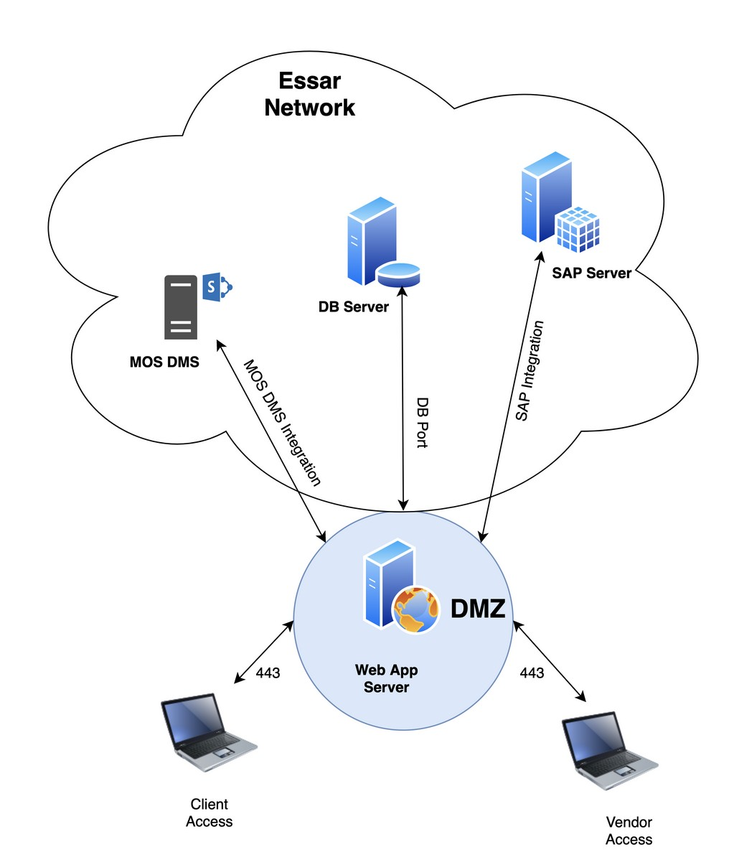
Figure 2 High level diagram of application interaction with other services and systems

Usage of internal libraries

With years of first-hand experience in various enterprise and Realtime application development, we have developed various re-usable software components which can be re-used at various places in the software development lifecycle. The benefits are not just limited to:
- Saving development time
- Reusing existing component
- Modularisation

Internal team members and vendors will be required to integrate their solutions with standard component libraries developed by Essar IT Development team. Some of the examples of such packages are:

- Master Data management: A module to create configurable master screens and backend code so that less time is spent in creating new master screens each time, instead simple configuration will enable the developers to dynamically create master screens.
- Roles and Permission manager: A module to manage the roles and permission of the users and provide role based access control mechanism.
- Audit Trails: Audit trails to maintain the history and versioning of models and database tables.
- Workflow management: A module to maintain the workflow and states of given approval process.
- Dual LDAP Authentication: Redudant Fallback for multiple LDAP Servers.
- Project Generator: A utility to generate project structure as per standard practices. Helps bootstrap project and ensure consistency in code structure.
- Essar React UI Library: UI Library to maintain consistency of look and feel across all Enterprise Applications.
- Email Notifications: Service to manage Email Notifications to and from the application.
- SMSClient: Service to manage SMS Notifications to and from the application.
- Whatsapp Notifications: Service to manage Whatsapp Notifications to and from the application.
- Logging: Standard logging library for designed for usage across all applications for technical audit and debugging purposes.
- Excel Uploader: Utility to upload and process data in excel.
- PDF: PDF Converter utility common across all applications.
- Scheduler: For scheduled tasks and batch tasks.
- Service Framework: Automation of REST/SOAP service generation from descriptors.
- SSO: Single Sign on policy library for enterprise applications.

Front End

React Libraries / Modules:
Following libraries and modules can be used as per requirement:

- React-Routing: For routing and navigating between multiple views in React Single Page application.
- Axios: For Ajax request to applications
- Ag-Grid Community Edition: For Grid Component.
- React-Redux: Flux based library for state management. Case by Case basis only after approval during design phases.

Screen Views

Following are basic levels of views

Figure 4: Screen Views and Templates

- Pre-Login Portal Views
- Login View
- Navigation panels
- Form Views
- List Views
- Report Views

Grid Component

Following are the features which would be expected from a grid / data table:
- Field level filters and search
- Column sorting
- Pagination
- Should be able to work with large data sets and on demand data loading (deferred scrolling)
- Toolbars.
- Grouping (Columns and row grouping)
- Inline editing where required
- Context Menu
- Drag and Drop (Sequencing of Cols and Rows)
- Custom formatting and highlighting on cells / rows / cols based on conditions
- Scroll Freeze

UI Component
- Forms:
  - Ant Design (Free and Community Edition Only).
- Router:
  - React-router should be used for routing purposes.
- Grid:
  - Ag-grid (Free and community version) to be use for grid component.
  - In case other components are used should be decided on case by case basis.

Modular, Portable and Higher Order Components

Developer should ensure following matrix which developing React Components :

- Modular Components: Developers should make a habit of using a DRY(Don’t Repeat Yourself) Approach. Where possible apply the concept of reusability and create modular components which can be reused at other places in the code. Redundant code should be avoided wherever possible.
- Portable Components: Whenever possible make the 3rd party modules portable. The wrapper functions and classes should be designed in a such a way that change in 3rd party component should have minimum impact on change in number of lines of code to port to new module or library.
- Higher Order Components: React recommends higher order components for better reusability and portability. A higher-order component (HOC) is an advanced technique in React for reusing component logic. HOCs are not part of the React API, per se. They are a pattern that emerges from React’s compositional nature.

Backend

Data Modeling
- Django models can be used to model the tables for using the Database API and ORM
- Django Database API can be used for ORM Purposes.
- In case of complex table joins and nested Queries for Reports and other business logic execution, SQL Queries can be executed using helper functions.
- Libraries like SQLAlchemy can be used where required upon discussion and approval.
- All Backend code, Models and Business logic should be DB Independent. The Application should be able to port to another DB. This should be on approval basis with ESIL Architect.
- Stored procedures should not be used for transaction related database operation. If required should be discussed with ESIL architect and used only after approval in exceptional cases.

Serializers – DRF
- Serializers should only contain mapping between models and fields to be serialized.
- Hook based event functioning should be established for all serializers where possible.
- Business logic should be written in standard business functions and libraries, at the most in ViewSets and not in serializers.

Audit Trail
- Audit Trails for important transaction and master screens needs to be done
- Individual screen level audit history and global admin level report needs to be created in all systems.
- Django reversion can be used for purpose of creating audit trail.

Roles and Permission

Following levels of RBAC and ACL to be maintained:
- Module Level
- Screen Level
- Field Level

Logging

Following logs have to be maintained in separate files in the system:

- DEBUG logs should be written for entry/exit into each block of code.
- INFO logs should be written for a beginning and end of a logical activity or important points within the activity.
- WARNING logs should be written for situations where the program is not crashing, but something unexpected has happened, which may create problem in future.
- ERROR logs should be written if some function cannot be performed due to an abnormal condition.
- CRITICAL logs should be written if the program is about to crash due to an abnormal condition.

